**COMP4423 – Computer Vision**

**Project Requirement**

**Fashion Image Generation**

**[Deadline:** **23:59:00 Sun 30th April 2023]**

**1. Task Description**

Sheila, a professional fashion designer, is accustomed to creating a diverse range of clothing and accessories in various styles as it forms a part of her daily routine. However, this process can be quite stressful for her, and she would appreciate an application that can automatically generate a plethora of fashion images.

Your task is to develop a back-end algorithm and model for this application, which is able to:

1. Generate a diverse range of **QUALITY** plethora. Sheila is not expecting high-resolution images, but rather ones images similar to those in the provided fashion dataset;
2. Generate images with a **CONTROL** label (e.g., T-shirt/top, Trouser, Pollover);
3. Generate the plethora with **VARIETY**, meaning plethora generated with the same control label should be different from each other to some extent;
4. We provide a fashion image **Dataset** for learning. Some examples are shown for your reference. However, feel free to extend the dataset;
5. To ease your implementation, we provide a GAN-based **Sample Model** which generates plethora but not with the expected quality. You can either start from this model or build one completely by your own;
6. This is a group project with a maximum of **THREE** group members per group. You must **REGISTER** your group on Blackboard for submission.

**2. Details of the Dataset**

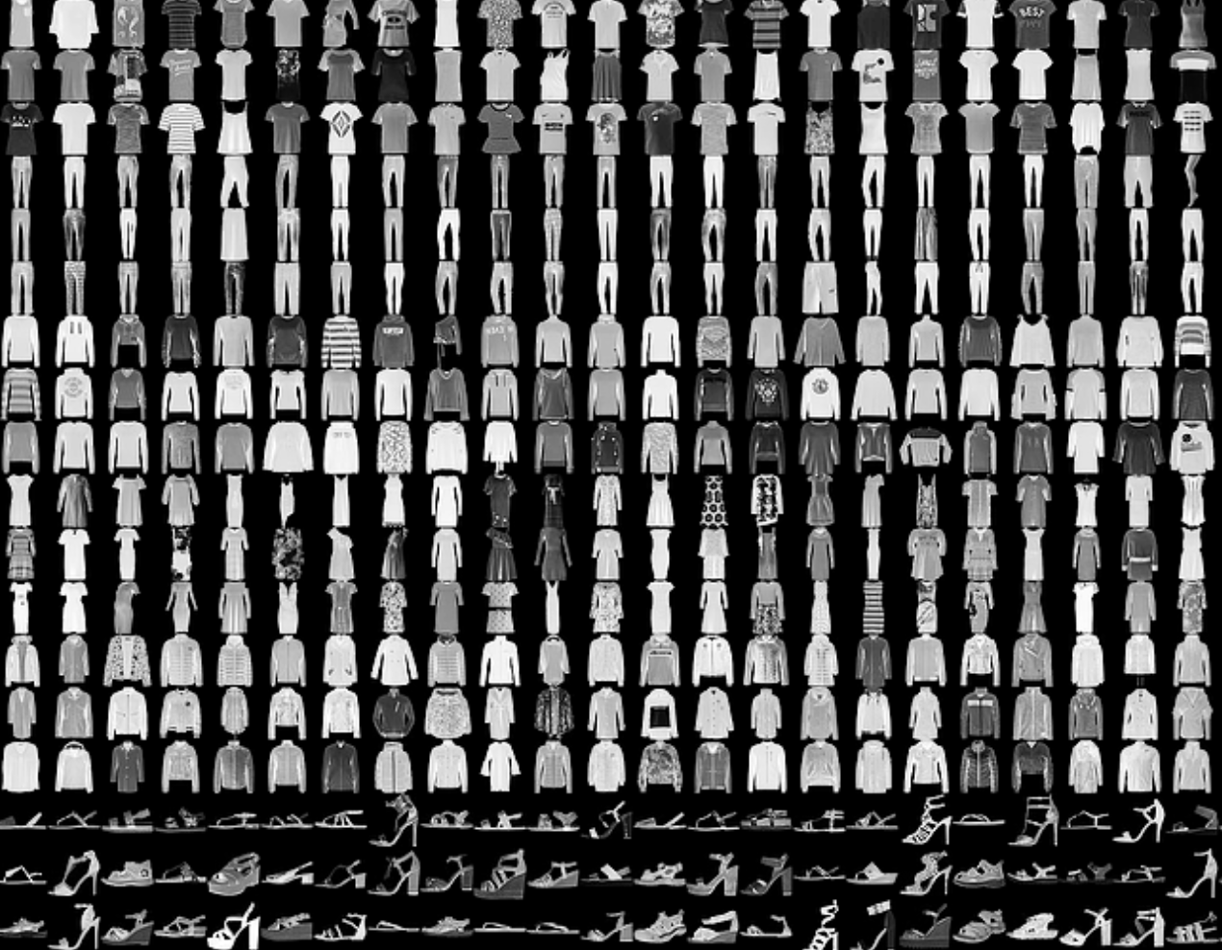

The dataset consists of 60000 images for training a neural network and another 10000 images for testing the generalization performance. Each example is a 28x28 grayscale image, associated with a label from 10 classes. The images and correspondent labels are stored in the .csv files (you can download the .csv files for training and test on Blackboard), shown as follows:

The first column is the label identifier for each image. The following 784 columns store the flattened pixel values for an image with size 28*28.

Each training and test example is assigned to one of the following labels:

Label Description

0 T-shirt/top

1 Trouser

2 Pullover

3 Dress

4 Coat

5 Sandal

6 Shirt

7 Sneaker

8 Bag

9 Ankle boot

3. Tasks and Assessment

***Please submit a single .py file and a report pdf file***

**Task 1: Preprocess the fashion image dataset and visualize some example images. (10 marks)**

**Task 2: Implement a base model that is capable of generating fashion images randomly (without control labels) and evaluate its performance on the test set using human judgment. (20 marks)**

**Task 3: Identify the limitations of the base model and propose some potential methods to enhance its generation quality. (25 marks)**

**Task 4: Implement the suggested improvements to the base model and validate its performance on the test set. (20 marks)**

**Advanced Task: Develop a model that can generate fashion images with controllable labels. For instance, the model should be able to generate different styles of trousers when given the "trouser" label. (25 marks)**

**Bonus:** *Submissions with excellent code quality (including comment quality), output accuracy, report quality and finishing quality of advanced tasks will be given bonus of no more than 20 marks (the final grade of this assignment will be* min (100, normal_grad+bonus)*).*

4. Submission

Follow the steps below:

1. Name the .py file as Project_<your_ID>_<your_name>.py.  
   *e.g.*, Assignment2_12345678d_CHAN_Dawen.py
2. Name the report as Project_<your_ID>_<your_name>.pdf.

*e.g.*, Assignment2_12345678d_CHAN_Dawen.pdf

1. Compress the two files into a .zip file and rename the .zip file.

*e.g.*, Assignment2_12345678d_CHAN_Dawen.zip

1. Upload the .zip file to the blackboard system.

**Warning:  
If you are unable to complete the whole program, try to accomplish part of the tasks and make sure it can run successfully.**

**Any wrong file naming and submission will be given a ZERO mark in this assignment.**

The deadline for this project is **23:59:00 Sun 30th April 2023**.

**Late submission penalty**

10% is deducted for each day that the work is late. The penalty will be applied up to a maximum number of three days after and including the submission deadline day. After three days the work will be marked at zero.

**This assignment is individual work. All work must be done on your own. Plagiarism is a serious offence. Copying code from web resources is prohibited as well. Any plagiarism case (for both the copier and the copiee) will be given a ZERO mark in this assignment.**